CHAPTER 1

INTRODUCTION

1.0 Background of Study
E-commerce or Electronic Commerce is the buying and selling of goods and services over any digital platform which enable buyers to shop from wherever they are. An online marketplace is a third-party platform like a website or an app where different independent sellers can operate storefronts to display and sell their goods to people that want to buy. Some popular online marketplaces are Amazon, Jumia, eBay, AliExpress, etc. An online marketplace is a type of e-commerce platform so all online marketplaces are e-commerce platforms but not all e-commerce platforms are online marketplaces. The website of a specific store like Zara for instance is an e-commerce platform but not an online marketplace because it is not a third-party platform, and there is absence of multiple sellers on the platform.
E-commerce uses the internet to change how people buy and sell goods and services, removing distance limits and changing traditional business methods [1]. E-commerce offers many benefits to both consumers and sellers. For consumers, it provides convenience, allowing them to shop anytime and anywhere, compare products easily, save time, and access a wider range of goods beyond their local markets [2]. E-commerce helps sellers reduce their operating expenses, increase the sales they make, improve their client-customer relationships, brand visibility and communication capability [2].
During the past decade, internet usage has had a significant impact on e-commerce growth in Nigeria, with broader internet access, the uprising of mobile technology and the evolution of safe online payment systems, the e-commerce sector in Nigeria has progressed from an emerging industry into a thriving sector [3]. According to PCMI study, Nigeria’s B2C e-commerce sector was valued at US$15 billion as of 2023 and is predicted to grow to US$33 billion by 2026 [4]. This boom caused platforms like Jumia, Konga, Jiji have become household names, they offer variety of goods through online marketplaces.
However, there is still a lot of e-commerce activities taking place on informal platforms like social media. The findings from a study at Federal Polytechnic, Nekede shows that a lot of students and staff use social media platforms like Facebook and Instagram for e-commerce activities [5]. This trend is not limited to Federal Polytechnic, Nekede, similar patterns can be observed across other tertiary institutions in Nigeria where more students buy and sell through various social media channels.
In Babcock University, students buying and selling have become very common as a lot of people have started online businesses as a source of income. People buy and sell variety of products ranging from clothing, gadgets, skincare, accessories, etc amongst themselves. Most of these activities take place through channels like WhatsApp status, group chats, snapchat stories, broadcast lists and words of mouth. Although these methods ensure fast communication, they are unsafe and lack a centralized platform where all products and services can be viewed easily. This may cause sellers to struggle with low visibility and buyers finding it difficult to find trustworthy vendors. This method exposes students to risks of scams, miscommunication and unverified transactions, emphasizing the need for a secure and well-organized online marketplace dedicated to the Babcock University community.
An online marketplace dedicated to the Babcock University community would address the challenges by creating a centralized, verifiable and user-friendly environment for student entrepreneurs. There would be a central system where all products and services can be accessed easily by everyone. The system will also provide student verification which ensures security and trust on the platform. This proposed system will provide more visibility for student vendors and encourage more students to engage in entrepreneurship.
In conclusion, our project attempts to design and implement an online marketplace for Babcock University students. This will ensure a safe and convenient platform to buy and sell on campus. Most student entrepreneurs already sell through informal platforms like social media so this will give them a more structured platform for their businesses to grow and reach a wider audience.

1.1 Statement of Problem
In Nigeria currently, online buying and selling has become very common. E-commerce is fast gathering momentum and becoming a reality in Nigeria as in other parts of the world [6]. In 2019, Nigeria’s B2C E-commerce Index score was 53.2, ranking it fourth in Africa, this index assesses a country’s readiness to support online shopping based on several key factors [7]. Nigeria ranks among the African nations with the highest number of online marketplaces with the most popular marketplace based on number of visitors Jumia [7]. Yet, there is lack of a dedicated platform for most university communities.
In Babcock University, there are numerous students running businesses selling a number of things and offering diverse services as well. Most student entrepreneurs make use of social media like TikTok, WhatsApp and/or Snapchat and spreading the word by mouth to reach their target audience. Although this works for some businesses, many do not benefit from this structure as it only targets a specific set of people.
This informal system presents several challenges for both buyers and sellers. Buyers may find the current system difficult to trust because of the high risk of scams and difficulty finding trustworthy sellers. Students lack a proper platform to promote and commercialize their products or services, leading to lack of expansion in their business [8]. Some students often face communication challenges with their customers and some struggle with customers who delay payments or fail to pay altogether [8]. General marketplaces are too broad and cannot fully accommodate the specific and localized needs of students [9].
While there is the existence of large platforms like Jumia, Konga, Jiji, and so on, they do not cater to the university community and cannot verify student identity to track business transactions within school. In conclusion, the online marketplace for university students aims at creating a trusted, user-friendly, school-based platform that makes buying and selling easier for Babcock University students. This will also make it easier for students to locate reliable student sellers for things they need. Hence, there is a need for a specialized online marketplace designed to meet the unique commercial and security needs of students within a university community.

1.2 Aim and Objectives
The main aim of this study is to design and implement an online marketplace platform that is created exclusively for Babcock university students. The specific objectives of this study are to:
- design an online marketplace for Babcock University.
- develop an online marketplace for Babcock University.
- evaluate the developed online marketplace.

1.3 Methodology Overview
We will use a structured method based on the Software Development Life Cycle (SDLC) model. The process will involve both development and user focused research so that the platform actually meets student needs.
Requirement Gathering
We will collect information by exploring existing studies. The aim is to understand challenges when using social media channels and the existing online marketplaces and what features would make the platform more attractive to students.
System Design
We will design the system showing how each of the parts will interact with each other. The main aim is to design a system that prioritizes security, usability and performance.
Implementation
The system will be implemented using:
Frontend: HTML, CSS, and JavaScript with React framework.
Backend: Java and SpringBoot
Database: PostgreSQL for data management.
The platform will also include a verification feature using students official university emails to ensure that only students can register.
Testing and Evaluation
The system will be tested and evaluated based on these metrics:
- functionality
- usability
- performance
- security

1.4 Scope of the Study
The scope of this project includes the creation of a platform like Jumia, Konga and Amazon, tailored specifically to Babcock University students. The system will allow verified Babcock university students buy and sell on a secure and user-friendly platform. The key features will include user registration and authentication using official university email, item listing and control, search and filtering, direct messaging and a review and reporting system to enhance user trust. A payment feature will be integrated to allow seamless transactions on the platform and an admin dashboard will be developed to track user activities. The system will be a web-based application accessible across various devices and screen sizes.
The primary aim is to deliver a functional online marketplace for Babcock university students and will not include deployment across multiple institutions, advanced delivery systems or implementation of advanced features like AI-driven recommendations. Limiting the study to a Babcock University allows for controlled testing, easier data management, and focused feedback collection.

1.5 Significance of the Study
The significance of our project, which is like Jumia but tailored to the needs of Babcock University students, is the ability to address the need for a safe and organized platform for buying and selling on campus. Most students depend on social media platforms to advertise and sell their goods but this can lead to issues of distrust, scams, miscommunication and limited visibility. This project will remove those issues and make buying and selling within campus better.
Our project is also significant in encouraging entrepreneurship among students. It helps empower student entrepreneurs by making their businesses more efficient. This fosters business growth, skill development, creativity and work experience among students as they gain experience running their own ventures online.
In addition, the project is valuable in a technical and social scene as it integrates trust, convenience and e-commerce practices into one system designed for the university. The project helps the campus stay more connected on the e-commerce scene by providing safe transactions and fast product discovery. The project shows us the use of tech in create solutions that meet student needs while also following the universities guidelines.

1.6 Definition of Terms
The following definitions explain some terms used during this project:
- Online marketplace: A website or app that brings together different independent sellers and buyers in one platform to list, discover and transact goods or services. Such platforms generally mediate listing, discovery and sometimes payments [10].
- Student verification: The process used to confirm that a registrant is an enrolled student at Babcock University via institutional email, single-sign-on, or student ID validation. This reduces impersonation and external abuse [11].
- User authentication: This is the technical process in which the system confirms a user’s identity. Authentication is needed to enforce student-only access.
- Seller profile: The public page for a student who lists items or services; it typically shows the seller’s name/handle, biography, listings, and aggregated ratings/reviews from prior transactions [9].
- Product or Service listing: This is a display of an item or service that includes title, description, price, category, availability, photos and seller contact options.
- Order / Transaction: This is the sequence that begins when a buyer commits to purchase (order placement) and ends when the exchange is completed (delivery/collection and payment settlement). In this project, an “order” may be completed offline (cash on meet-up) or via the platform’s payment feature.
- Rating / Reputation system: A mechanism that collects buyer (and optionally seller) feedback like numeric ratings and textual reviews to help future users judge trustworthiness. Reputation mechanisms are fundamental to trust in peer trading environments [12].
- Admin panel / Moderation tools: This is an interface that allows designated staff or moderators to verify users, approve or remove listings, resolve disputes, and enforce community rules. Proper moderation design reduces harmful content and preserves user safety [13].
- Digital wallet (in-platform wallet): A software account used to hold credits, accept payments, or send payouts within the platform. Wallets can be implemented as simple ledger balances (no banking integration) to support escrow or faster peer payments; security and usability are critical for adoption [14].
- Buyer / Seller: Buyer is a verified student who browses and purchases listings. Seller is a verified student who lists goods or services for sale.

Organization of the Project
This project will be organized like this:
- Chapter 1 - Introduction: This chapter includes the background, problem statement, aim and objectives, significance of the study, definition of terms and scope of the study.
- Chapter 2 - Literature Review: This includes the exploration of relevant literature on marketplaces, verification and reputation systems and campus commerce examples.
- Chapter 3 - System Analysis & Design: This involves stating the requirements, use-case diagrams, flowchart, sequence diagram, system architecture diagram and ERD.
- Chapter 4 - Implementation & Testing: This will show the implementation of the system, technologies used, frontend and backend implementation details, verification and reputation modules, payment design (if implemented), test cases, usability testing results and performance measurements.
- Chapter 5 - Conclusion & Recommendations: This will present the summary of the whole project, evaluation against objectives, limitations, and recommended future improvements.

CHAPTER TWO

LITERATURE REVIEW

2.0 Introduction
The growth of e-commerce and online marketplaces have changed the way people buy and sell over the past few years. Existing platforms have restructured traditional commerce by giving buyers access to a wide range of products all on the same platform. Buyers can now pick up their phones to buy something and it will be delivered to their doorstep. They have also given entrepreneurs the opportunity to reach a wider range of people. The existing systems provide convenience but are too wide for smaller communities like the university campuses. This causes most student vendors to resort to social media to market and sell their goods.
In Nigeria, many student vendors have turned to online platforms to sell their products. This method although flexible, maybe lack verification, visibility and secure transactions. This creates a gap between the demand for online marketplaces and the needs of university students.
It is necessary to understand how online marketplaces work and the technology behind them in order to design a system suited to Babcock university. This chapter reviews suitable literature related to e-commerce and online marketplace; trust, security, and user verification in online marketplaces; campus-based marketplaces and technology adoption and usage among students. The aim is to recognize the strengths and weaknesses of existing systems and to highlight things that will help design and implement the project.

2.1 Historical Background of the Research
The creation of internet in the early 1990s sparked the introduction of e-commerce. The initial innovators Amazon and eBay, founded in 1994 and 1995 respectively, proved that commerce can function very well even without a physical shop [15]. These early marketplaces mostly made use of business-to-consumer (B2C) model and focused on payment systems, delivery of goods and building customer trust.
The marketplace model kept becoming more popular as technology progressed because it allowed multiple independent sellers to operate on one digital platform. This method improved efficiency, increased access to variety of products and enhanced scalability [16]. Online marketplaces eventually evolved into what is called the platform economy where digital systems take care of value exchange between users through data management, governance and matching algorithms [17].
By the 2000s and 2010s, marketplaces had evolved into expansive digital ecosystems that incorporated customer feedback, identity verification, recommendation algorithms and mobile apps [18]. The widespread adoption of smartphones changed e-commerce even more by leading to the rise of mobile based marketplaces. Real-time chat, online payment and geo-location tracking features became very important for ensuring convenience and trust [19].
Recent data shows that third-party sellers represented approximately 72 percent of total marketplace sales in 2014, a number that increased to 81 percent by 2024. By 2025, online marketplaces are forecasted to generate roughly USD 2.4 trillion in global retail sales [20].
In Nigerian, there are many factors that still limit widespread marketplace adoption. Findings shows that logistics, trust and infrastructure are major issues [21]. Only about 30 percent of deliveries get to customers outside major cities as a result of severe last-mile challenges [22], [23]. These problems show that it is important to adjust to local needs when creating platforms for students by including easy ways to pay, safe ways of verification and dependable ways to deliver on campus
In summary, the way online marketplaces have changed teaches us that for student-focused platforms, the need for reliable systems, strong trust systems, smooth delivery or pick up and easy mobile interaction. Taking care of these factors within our immediate environment is the key to making a sustainable student marketplace platform.

2.2 Overview of Existing Systems
An online marketplace is a concept that exist both locally and globally through platforms such as Jumia, Konga, Amazon and Facebook Marketplace. They all offer a platform for businesses to display their goods for sale and for customers to buy. However, these are targeted towards the general public and not for small businesses on campus. This makes it necessary to have a specialized system.
Online marketplaces like Jumia, Konga, Amazon and others allow users to register, list products for sale and make simply make purchases from their devices. These platforms offer a number of features which make buying and selling easier. Despite these benefits, most online marketplaces are too wide to adequately meet the specific need of college students and the academic community [9].
Although current online marketplace systems are beneficial, there are still a number of issues that restrict their use for certain communities. The major challenge faced by both buyers and sellers in school communities is the absence of a dedicated platform to showcase their products or services, there is also limited access to information about these businesses, as most interactions take place through instant messaging apps like WhatsApp, snapchat and other social media platforms [8]. This is because most existing systems are too broad to serve student communities effectively.
Furthermore, trust remains a major concern in these existing systems. The inability of peer-to-peer e-commerce platforms to ensure the safety of their users has shown serious risks, particularly with the recent rise in online shopping activities [24]. Furthermore, current platform that we have do not check validate users as students, which raises the possibility of fraud and makes it challenging to guarantee secure student transactions.
These restrictions emphasize the need for a more specialized platform created especially for the Babcock University community so students can buy and sell easily within the campus and promote trust through user verification, among other benefits.

2.3 Review of Related Works
E-Commerce and Online Marketplaces
E-commerce and online marketplaces have transformed business operations by introducing speed, convenience and global reach over the years. Taher [25] claims that when compared e-commerce platforms offer greater market accessibility, year-round purchasing, customer convenience and more. The author also pointed out limitations including fraud, limited customer service, security issue, delivery delays and so on.
The impact of growing e-commerce on local company practices and marketing was examined by Vohidovna, Ozad, and Zilola [26]. According to the paper, small and local firms can reach larger customer bases and collect consumer data for targeted marketing. The authors also noted limitations that prevent local businesses from fully benefiting like internet costs, delivery problems and deficiencies. These findings mean that the university marketplace should be easy to use on slow internet and set pick-up or delivery options that work on campus.
Nigeria's unique e-commerce adoption patterns are documented in Okolie & Ojomo's study [27]. According to the report, e-commerce has improved awareness for Nigerian sellers, expanded consumer choice and encourages entrepreneurship. It also documrnts persistent issues like shaky logistics networks, low trust in online payment methods, poor regulatory enforcement, and low digital literacy in some segments. The authors recommended local solutions such as verified payment options, seller verification, and awareness campaigns, all of which are also very relevant to a marketplace aimed at student users.
Wahab & Abdulmajeed’s study [28] investigate how digital marketplaces affect consumer engagement. They discovered that with personalised offers and interactive features, marketplaces may promote customer engagement while also increasing transparency and competition. However, it also notes that too much competition may reduce profits for small sellers and that rules about ratings, dispute handling and transparency significantly shapes user trust and outcomes. For this project, the study suggests having clear rules, straightforward dispute resolution processes and features that support small student sellers’ visibility and fairness.
Therefore, the proposed system should focus on security, user verification, and suitable campus delivery methods while also including features that improve visibility and fairness for student sellers. Putting these in place will help address the issues found in previous studies and make the platform more useful and appealing to the university community.

Key Findings:
- Although e-commerce has many advantages for businesses and consumers, it has substantial technological and non-technical drawbacks so for broader adoption, security, logistics, and trust mechanisms must be improved [25].
- Growth in e-commerce increases the reach of local businesses and makes data-driven marketing possible, but some limitations and regulatory obstacles limit local market gains [26].
- Although the Nigerian e-commerce market encourages entrepreneurship and increases merchants' visibility, it is hindered by inadequate logistics, a lack of trust in payments, and regulatory loopholes; localised solutions such as awareness, campus fulfilment, and verification are advised [27].
- Digital marketplaces improve engagement and market efficiency through interactivity and personalization, yet policy and fairness issues like ratings, dispute resolution and transparency can undermine small sellers and user trust [28].
Trust, Security, and User Verification in Online Marketplaces
For online marketplaces to be successful, trust and security are crucial elements. The users must have faith that their financial and personal data is secure and that transactions will go as planned. Numerous research have examined how user engagement and sustained use of online marketplaces are influenced by user trust, identity verification, and platform dependability.
Vinay [29] talked about using data-driven identity verification to fight online marketplace fraud. According to the study, the risks of identity theft and fraudulent listings are greatly decreased by platforms that use automated verification technologies like biometric identification and document validation. The author claims that implementing such verification technology boosts user confidence, platform credibility, and transparency. This highlights the importance of using an institutional verification system in this system, where identity assurance can help maintain a secure community of buyers and sellers.
In the same way, Jang & Kim [30] looked into what influences consumers' loyalty and trust in consumer-to-consumer (C2C) marketplace systems. According to their research, consumers' loyalty and continuous participation are significantly impacted by both platform and interpersonal trust. They came to the conclusion that maintaining confidence over time requires design elements that improve dependability, openness, and user feedback channels. This implies that incorporating open review procedures and reliable means of communication can strengthen community trust for the proposed university marketplace.
Musa, Amusa, & Adeyinka [31] carried out an assessment of e-commerce usage among students in tertiary institutions in Abeokuta, Nigeria, identifying trust and security as the most significant challenges to e-commerce adoption. Their study revealed that students were reluctant about online payments and feared the possibility getting scammed due to insufficient identity verification and poor regulatory oversight. The authors recommended enhancing trust through institutional verification systems, secure payment methods, and digital literacy awareness which are measures that are also essential in this project.
Overall, the reviewed study demonstrates that the basis of a successful online marketplaces are trust, security, and verification. Strong verification procedures, open user feedback, and safe payment options can greatly boost user confidence and make the market safer and more dependable for both buyers and sellers.
Key Findings
- Identity theft and fraudulent listings can be decreased by using data-driven verification techniques like biometric authentication and document validation [29]. In marketplace transactions, automated verification solutions increase transparency and boost user confidence [29].
- In C2C markets, platform trust (safety and dependability) and interpersonal trust (user trust) have a significant impact on sustained use and loyalty [30]. Maintaining confidence requires open review procedures and reliable routes of communication [30].
- Trust and security remain major barriers to e-commerce adoption among students. Inadequate identity verification and low confidence in online payments discourage participation. The study recommends institutional verification, secure payment methods, and digital literacy initiatives to strengthen user trust [31].
Student-Oriented or Campus-Based Marketplaces
University students engage in a wide range of small-scale commerce like selling textbooks, clothes, accessories, tutoring services and more.
A recent Nigerian study by Chukwudum & Victor [32] describes a student-centered digital marketplace (“Small Pocket Money”) aimed at micro-entrepreneurs within universities; the platform emphasizes institutional verification and intra-campus trade.
Another project, titled “Student-Centric E-Commerce Platform for Local Business Growth”, built at the University of Port Harcourt, Nigeria, tailored filters to show goods within a student’s university only, favouring peer trade and local relevance [33].
These works show the viability of marketplace platforms targeted at students rather than the general public. However, few peer-reviewed articles explore fully deployed student-only marketplaces, especially in African university settings. For example, existing systems often include listing and messaging, but lack integrated verification, reputation systems and campus-friendly payments. This gap signals the need for more practical research on student exclusive marketplaces.
Key Findings:
- Student-specific marketplaces can reduce market entry friction and foster peer trade [32], [33].
- Filtering by university and peer proximity improves relevance and trust [33].
- There is a shortage of rigorous evaluations of student-only marketplace systems, particularly in low-resource settings.
Technology Adoption and Usage Among Students
The adoption of new online platforms by students depends substantially on perceived usefulness, ease of use, trust, and facilitating conditions.
In Nigeria, a review study on e-commerce adoption identified security and trust as foundational for uptake in developing markets [34]. At a student level, a survey of Nigerian undergraduates found that convenience, product credibility and choice all significantly affect customer expectation and online behaviour [35]. These results are consistent with the Technology Adoption Model (TAM), which states that adoption is driven by perceived usefulness (PU) and perceived ease of use (PEOU); trust and risk perception also play important roles in transactional platforms.
This means that a campus-based marketplace needs to be straightforward to use, demonstrably beneficial (making student buying and selling easier than through other routes), and trust-building through reputational controls and verification.
Key Findings:
- Security, privacy and trust are key adoption drivers in Nigerian e-commerce contexts [34].
- For students, convenience, credibility and peer influence strongly shape online purchase behaviour [35].
- TAM and related models remain relevant; however, additional constructs (trust, personal innovativeness) must be considered in student-focused transactional systems.

2.3.1 Summary of Reviewed Literature
S/N | AUTHOR, YEAR | TITLE | METHODOLOGY | FEATURES | STRENGTH | WEAKNESS
1 | Taher, 2021 | E-Commerce: Advantages and Limitations | Descriptive and analytical review of e-commerce models, benefits, and drawbacks. | Discusses e-commerce types (B2B, B2C, C2C), advantages like accessibility, time-saving, and global reach; highlights technical and non-technical limitations | Provides comprehensive overview of global e-commerce operations and challenges | Lacks focus on localized or educational community-based marketplaces
2 | Vohidovna, Ozad, & Zilola, 2025 | E-Commerce Growth and Its Impact on Local Marketing | Qualitative analysis of local businesses adopting online platforms | Examines how e-commerce supports small/local businesses and data-driven marketing | Highlights e-commerce as a tool for local economic expansion and market efficiency | Limited discussion of trust and logistics issues; assumes adequate infrastructure
3 | Okolie & Ojomo, 2020 | E-Commerce in Nigeria: Benefits and Challenges | Empirical study using surveys on Nigerian e-commerce users | Identifies adoption barriers: poor logistics, low trust, and weak regulations | Provides local context and insights into e-commerce growth in Nigeria | Limited recommendations for platform-level technical solutions
4 | Wahab & Abdulmajeed, 2025 | The Rise of E-Commerce and Digital Marketplaces: Implications for Consumer Engagement and Market Efficiency for Consumer Engagement and Market Efficiency | Analytical study using secondary data | Explores effects of digital marketplaces on engagement, personalization, and fairness | Connects consumer behaviour with digital interactivity and transparency | Does not provide practical implementation strategies for small marketplaces
5 | Vinay, 2022 | Using Data-Driven Identity Verification to Fight Fraud in Online Marketplaces | Experimental and data-driven model evaluation | Explains use of biometric and document-based verification systems for fraud prevention | Demonstrates how automated verification improves transparency and platform credibility | Focuses more on technology than on user perception or behavioural trust
6 | Jang & Kim, 2023 | The Factors Influencing Users’ Trust in and Loyalty to Consumer-to-Consumer Secondhand Marketplace Platform | Quantitative analysis using user surveys | Investigates relationship between platform trust, interpersonal trust, and loyalty | Provides evidence-based insight on trust dynamics and feedback mechanisms | Study limited to Korean users; cultural and contextual differences may affect generalization
7 | Musa, Amusa, & Adeyinka, 2025 | An Assessment of Electronic Commerce Usage among Students of Tertiary Institutions in Abeokuta Metropolis, Ogun State, Nigeria | Quantitative descriptive research using questionnaires | Focuses on students’ e-commerce adoption and challenges of trust, security, and verification | Provides local, education-specific insights relevant to campus marketplaces | Does not include detailed technical recommendations or user interface solutions
8 | Chukwudum, Q. C., & Victor, O, 2024 | Creating Tailored Digital Markets for Student-Centered Micro Enterprises: A Case Study of the Nigerian Landscape | Case study of Nigerian university micro-entrepreneurs and digital marketplace prototype | Focused on student-only marketplace; institutional verification; local peer trading | Demonstrated the viability of student-exclusive marketplaces; identified benefits of university verification | Prototype not fully implemented; limited empirical testing
9 | Oghenekaro, L. U., & Briggs, T. (2024) | Student-Centric E-Commerce Platform for Local Business Growth | System design and implementation using standard SDLC | University-filtered listings, local product promotion, peer-to-peer interaction | Promotes intra-campus entrepreneurship; improves relevance of listings | Lacks integrated authentication and secure payment gateway
10 | UIJSLICTR (2021) | A Review of e-Commerce Adoption in Nigeria Based on Security and Trust | Literature review and secondary data analysis | Evaluates security and trust issues in e-commerce platforms | Highlights critical role of security and trust in technology adoption | Not focused on university or student context
11 | Adegoke, K. A., Aladejebi, O. A., Ojo, O. J., & Aladejebi, O. A. (2025) | Digital Marketing Determinants and Shopping Behaviour among Students of Federal University of Technology, Akure, Nigeria | Quantitative survey and regression analysis | Assessed how digital marketing factors influence student online buying behaviour | Identified ease of use, convenience, and credibility as adoption factors | Limited scope—focused only on buying, not selling or marketplace design

2.4 Strengths and Weaknesses of Study
2.4.1 Strengths of the Babcock University Online Marketplace System
- Encourages Student Entrepreneurship: By providing a platform for student vendors to display their products and services, the system promotes economic independence and entrepreneurship within Babcock University's student body.
- Campus-Based Convenience: Students may easily buy and sell goods without ever leaving campus thanks to this specialised online marketplace designed for the educational setting.
- Enhanced Trust and Verification: Students may easily buy and sell goods without ever leaving campus thanks to this specialised online marketplace designed for the educational setting.
- User-Friendly Interface: The system’s design prioritizes accessibility and simplicity which makes it simple for individuals with less technological expertise to browse, list, and buy products.
- Improved Visibility for Student Businesses: The marketplace gives student-owned businesses and brands that might not be seen outside social media channels more visibility.

    - Weaknesses of the Babcock University Online Marketplace System
- Limited Scope of Use: The system is restricted to only Babcock University students, which limits the systems range of use and excludes external users who might benefit from the system as well.
- Dependence on Internet Connectivity: Since the system operates online then poor network on campus could prevent the smooth operation and access of the system.
- Lack of Mobile Application Support: The system is web-based and is not available as a mobile app so this may reduce accessibility for users who rely mostly on smartphones.
- Limited Testing Population: Only a small number of students participated in the system's evaluation phase, which may not accurately reflect the whole university population or capture a range of user comments.
- No Advanced Fraud Detection Mechanism: The system does not currently have automated fraud detection or reporting elements that might further improve safety, in spite the existence of basic verification.

CHAPTER THREE

SYSTEM ANALYSIS AND DESIGN

3.0 Introduction
This chapter presents the system analysis and design for the online marketplace platform intended exclusively for university students. It begins by identifying what the system must do (analysis), and outlines how it will be structured and built (design). The process guides the journey from problem definition, peer-to-peer student trade within a campus environment, to the creation of a functional software solution that satisfies both user needs and institutional realities.
Within this work, the platform’s target users (verified university students) require a transaction environment that is safe, accessible and efficient. Accordingly, the methodology for developing the system balances software engineering practices with research design, ensuring the final product aligns with functional and non-functional requirements such as verification, search/listing, ratings and secure payments.
The chapter further justifies the research design choice, describes the system model and architecture, and illustrates how various design diagrams (use-case, sequence, ERD) map to the project requirements. Because this platform must adapt to evolving student needs and feedback, an incremental development approach was adopted to support iterative improvement, system validation and real-world refinement Invalid source specified..

3.1 Research Design
This study adopts a descriptive and developmental research design to guide the creation of the student marketplace platform. A descriptive design helps examine existing literature and digital trading systems to identify features, user flows and challenges. Meanwhile, the developmental side focuses on implementing those insights into a working prototype suitable for a campus environment.
Due to the project’s technical orientation, primary data collection (such as large-scale surveys or interviews) was limited; instead, the design draws on robust secondary data sources including academic studies on student e-commerce adoption and peer-to-peer platforms as well as technical frameworks that guide system architecture and user interaction design Invalid source specified.. By doing so, the study ensures that platform design reflects current user behaviour and technological practices.
The analysis component examines key marketplace elements: student registration/verification, listing creation and browsing, order processing, payment integration, and administrative control. Recognizing that informal student trading (via social media or campus noticeboards) often lacks verification and presents trust issues, the platform is designed with institutional-email validation, secure login, seller-ratings and moderator oversight to mitigate risk and encourage trust.
Finally, to accommodate evolving requirements and student feedback, the chosen development method is based on the incremental model: the platform is released in manageable modules, i.e. core listing features first, followed by wallet/payment integration and advanced filters. This approach promotes flexibility, encourages early user testing and ensures that the system evolves coherently with stakeholder needs.

3.2 Functional and Non-Functional Requirements
Functional Requirements
- User Registration and login:
  - Student Seller, Student Buyer and Admin should be able to register and log in using their Babcock University email address.
  - Student Seller, Student Buyer and Admin should be able to verify account via email.
- User Roles & Access Control:
  - The system must support various distinct user roles (Student Seller, Student Buyer, Admin).
  - The system must enforce role-based access like only sellers can create listings; only admins can remove users.
- Profile Management:
  - The system should allow users to create and update profile information.
  - The system should show verification status on profile.
- Product Listings (create, edit, delete):
  - The system should allow sellers create listings with title, description, price, category, quantity, condition (new/used), location, images, availability, and tags.
  - The system should allow sellers edit or delete their own listings.
- Image Upload:
  - The system should support multiple image uploads per listing.
  - The system should have size limits and automatically reduce size of the image.
- Categorization and Tags:
  - The system should allow sellers add product categories and tags to allow for easier search and filters.
- Product Search and filtering:
  - The system should provide keyword search, category filters, price range, condition filter and sorting (newest, price low→high, relevance).
  - The system should support pagination.
- Product Details Page:
  - The system should display full item details: images, description, variations, seller info, availability, price, contact button, and reviews/ratings.
- Cart & Wishlist:
  - The system should allow buyers to add items to a cart for checkout.
  - The system should allow buyers save items to a wishlist for later.
- In-app Payment Integration & Checkout:
  - The system should be integrated with a secure payment gateway.
  - The system should only allow full payment for products before generating receipt.
  - The system should provide invoice/receipt after payment.
- Order Management:
  - The system should allow buyers place orders.
  - The system should allow sellers receive order requests and can accept/decline.
  - The system should update order status (Pending → Accepted → Processing → Ready → Shipped/Collected → Completed → Cancelled).
  - The system should be able to provide order history for both buyer and seller.
- Delivery /Collection Options:
  - The system should let sellers specify delivery options (meetup, campus pickup, delivery) and additional details like pickup location, etc.
  - The system should allow buyer to select preferred option (if there are many) during checkout.
- In-app Chat:
  - The system should allow real-time messaging between buyer and seller (in-app chat).
  - The system should preserve conversation history and allow attachments (images/documents).
- Notification System:
  - The system should send notifications (email and in-app) for important events: registration confirmation, listing approved, new message, order update, payment receipt, admin messages.
- Feedback or rating system:
  - The system should allow buyers to rate and review sellers and listings after transaction completion.
  - The system should allow admin moderate/remove abusive reviews.
- Report / Dispute Management:
  - The system should provide mechanisms for users to report listings or users.
- Admin Dashboard:
  - The system should allow admins manage users, review/approve verifications, remove listings, handle reported content, view platform metrics, and configure site settings.
- Moderation for Prohibited Items
  - The system should automatically flag or block prohibited items via keyword rules and admin review.
- Analytics & Reporting:
  - The system should allow admin to track key metrics like number of active users, listings, daily transactions, revenue (if applicable).
  - The system should allow admin to generate reports.
- Data Export:
  - The system should allow admin to export data in CSV/Excel.
Non-Functional Requirements
- Usability:
  - The system should have an intuitive and user-friendly interface that is easy to navigate for students with minimal technical experience.
  - The system should have buttons, icons, and forms that are clearly labelled, and important features such as search, listing, and messaging should be easily accessible.
  - The system should have consistent design and responsive feedback messages to enhance the overall user experience.
- Performance:
- The system should be optimized to load each page or perform user actions within a few seconds under normal network conditions.
- The system should handle multiple concurrent users without noticeable delay or degradation in response time.
- Security:
- The system should provide a high level of data protection through encrypted communication and secure password storage.
- The system should protect sensitive user data, such as login credentials and payment information from unauthorized access.
- Reliability:
- The system should be dependable and available for use at all times except during scheduled maintenance.
- The system should recover gracefully from unexpected failures and ensure that no data is lost during disruptions.
- Scalability:
- The system should be designed to accommodate an increasing number of users, listings, and transactions without major changes to its architecture.
- The system should continue to perform efficiently without affecting its functionality as the number of students or products grows.
- Maintainability:
  - The system shall be modular, allowing future developers to update or replace components easily.
- Portability:
  - The system should be platform-independent and compatible with major operating systems and web browsers.
- Accessibility and Responsiveness:
  - The system’s interface should be responsive, adapting automatically to different screen sizes such as laptops, tablets, and smartphones.
  - The system should have accessibility features like alt text for images to support all categories of users, including those with visual impairments.
- Data Backup and Recovery:
  - The system should perform automatic data backups at regular intervals to prevent data loss.
- Interoperability:
  - The system should be designed using standard web technologies to ensure it can interact smoothly with other institutional systems or third-party services, such as email verification and payment gateways.

3.2.1 Proposed Model Diagram
The Software Development Lifecycle (SDLC) gives a structured framework that guides the planning, design, implementation and testing of software projects. The proposed online marketplace system for Babcock University adopts the Incremental Process Model as its SDLC methodology because it allows progressive development and testing of individual modules before final integration.
The Incremental Process Model is a software development approach where the system is created gradually. Rather than releasing the entire system at once, it is developed and delivered in smaller sections known as increments. Each increment adds new features to the previous version until the full system is complete [36]. The process follows a cycle of requirement gathering, design, coding, testing, and implementation for each increment.
Unlike the Waterfall Model, where all requirements are implemented at once, the Incremental Model allows flexibility to make improvements based on feedback after each phase. This approach minimizes project risks, enhances early testing, and ensures that a working version of the system is available early in the development process.
The Incremental Model is considered most suitable for the proposed online marketplace system because the project consists of multiple independent modules such as user registration, product listing, search and filtering, payment integration, and admin management. Developing and testing each module individually ensures higher reliability and faster identification of errors.

This model also allows partial implementation during development reviews, enabling the project team to demonstrate progress at each stage. It is particularly appropriate for a student project with limited time and resources because it supports flexible scheduling and easy modification of requirements.

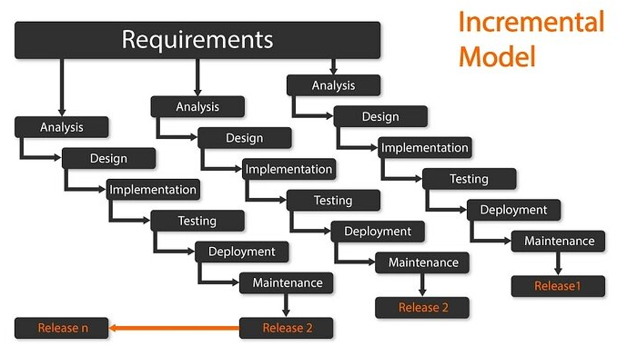

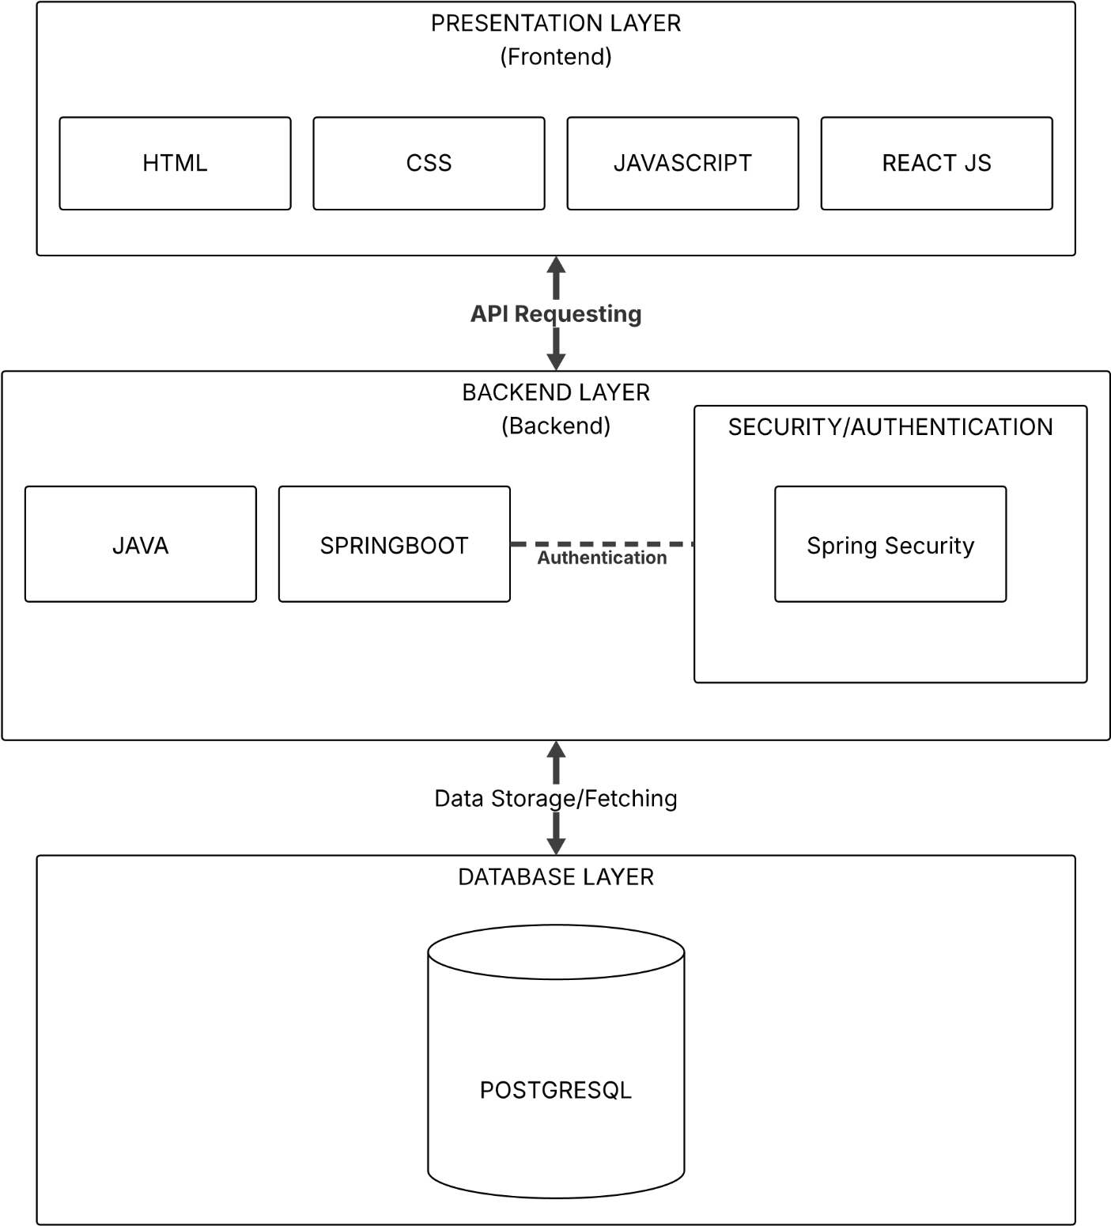
3.3 System Architecture

Figure 3.1: System Architecture of the Online Marketplace Platform

3.4 Relevant Diagrams

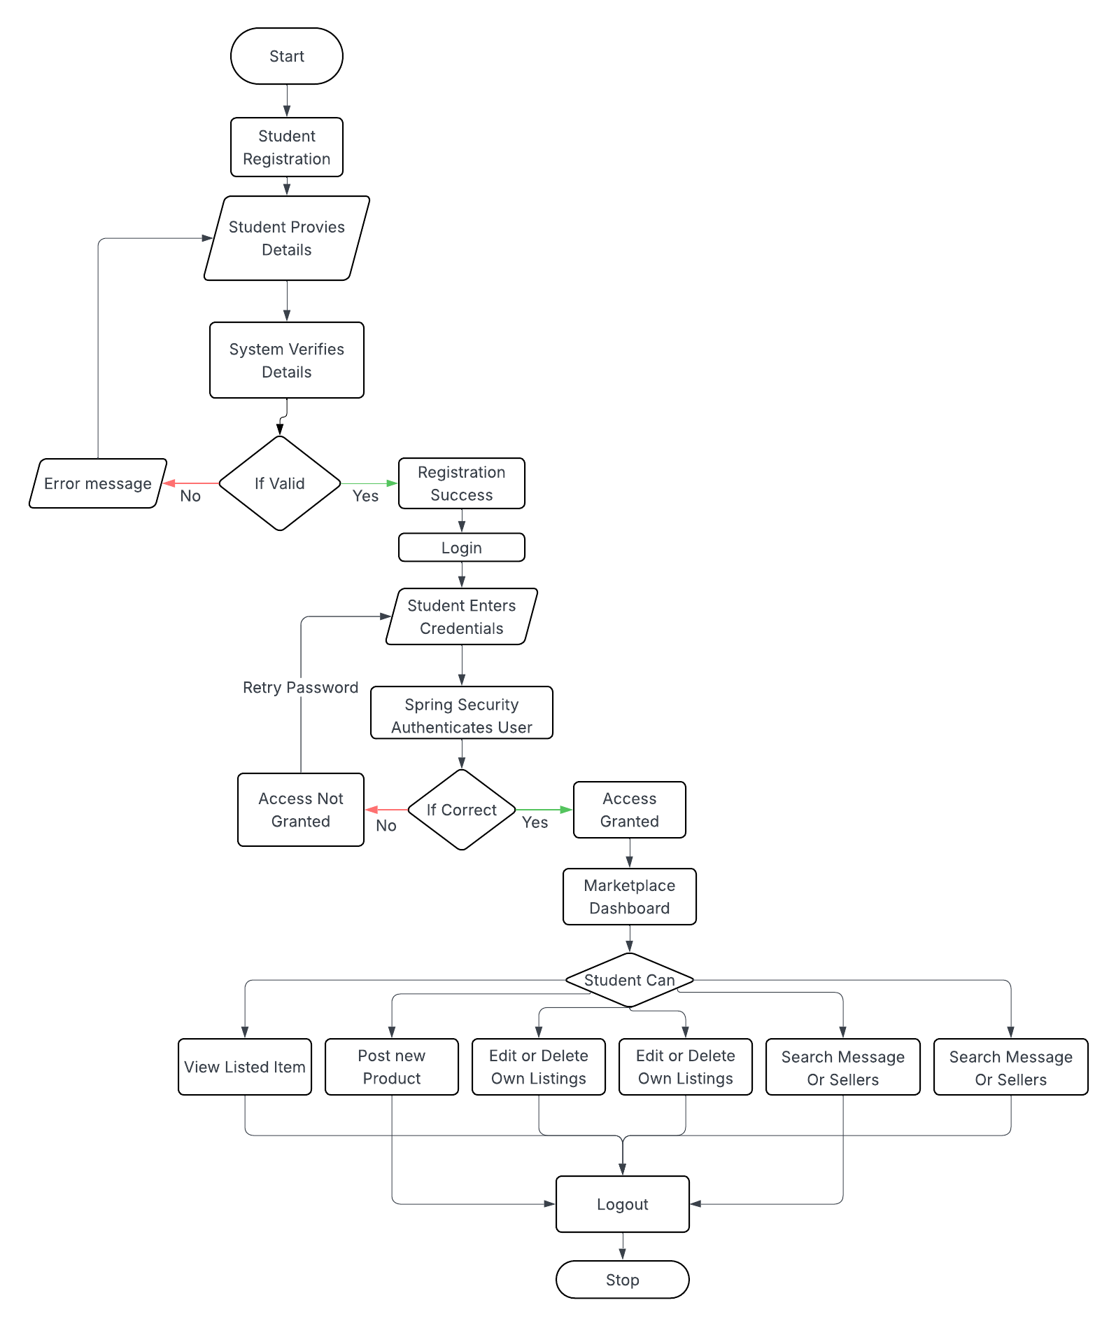
3.4.1 Flowchart Diagram

Figure 3.2: Flowchart Diagram of the Online Marketplace Platform

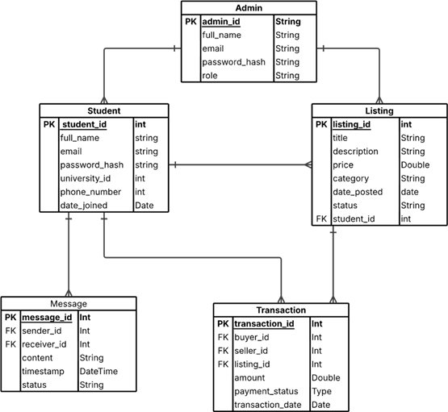
3.4.2 Entity Relationship Diagram

Figure 3.3: Entity Relationship Diagram of the Online Marketplace Platform

3.4.3 Use Case Diagram

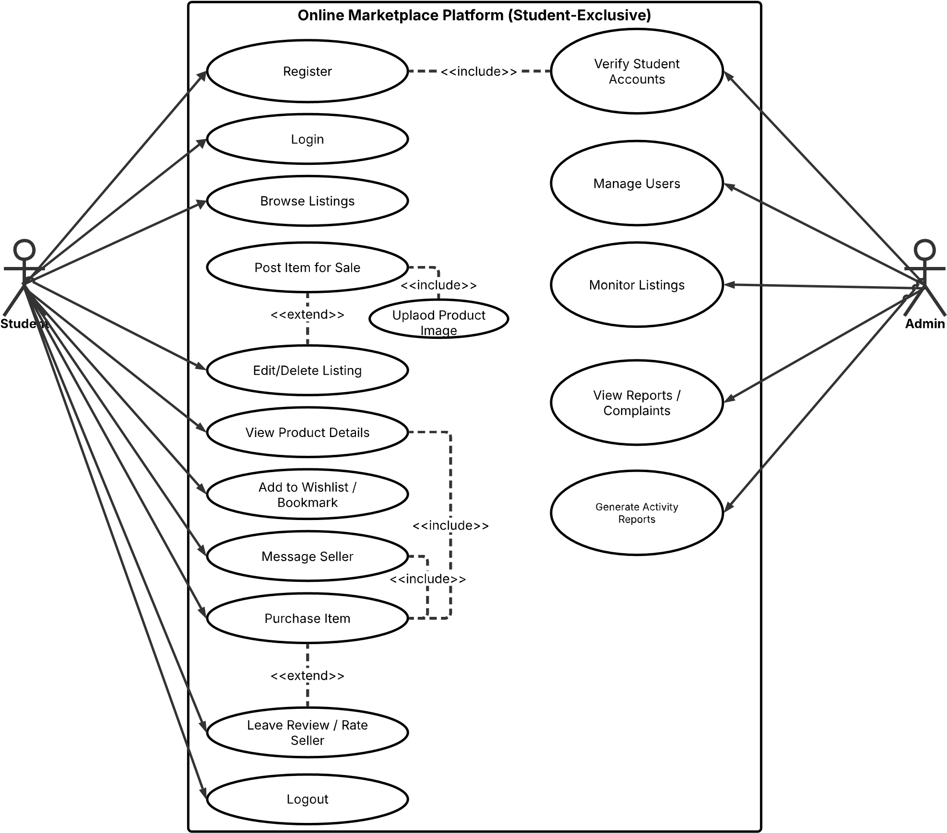

Figure 3.4: Use Case Diagram for the Online Marketplace Platform

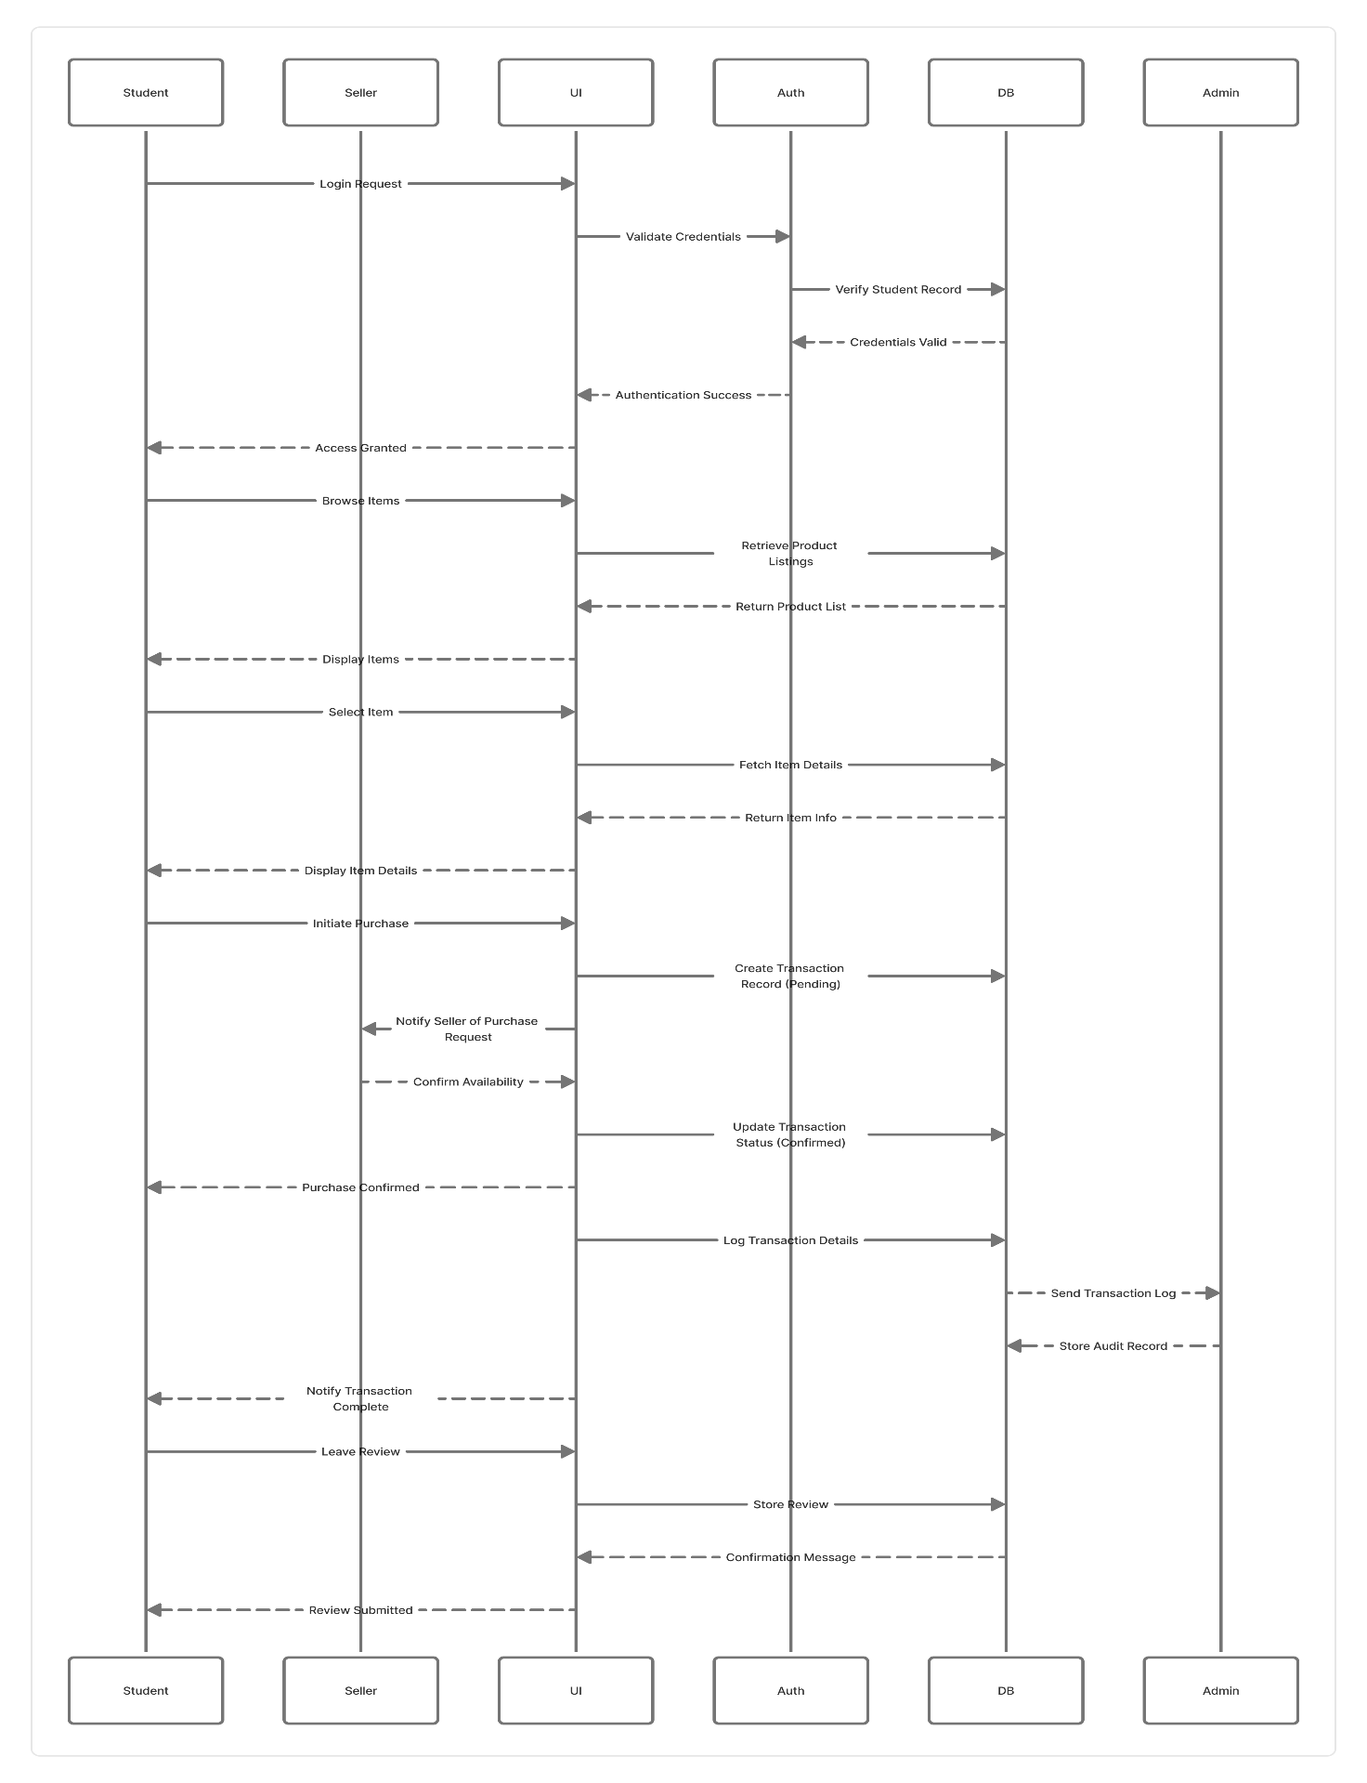
3.4.4 Sequence Diagram

Figure 3.5: Sequence Diagram for the Online Marketplace Platform

3.5 Development Tools
In building the proposed system, several technologies were carefully selected based on the system’s requirements, expected performance, and compatibility. The tools discussed below were chosen after evaluating their functionality, ease of use, and how well they integrate to produce a responsive and secure web application.
- HTML (Hypertext Markup Language)
HTML serves as the basic structure of every web page. It defines how information is arranged and displayed using elements such as headings, paragraphs, lists, tables, and images. Each element is represented by tags (for example, <h1> for headings or <p> for paragraphs) and may include attributes like id or class for additional styling and control. With HTML, developers can nest and organize elements logically, forming the layout upon which other technologies, such as CSS and JavaScript, operate.

- CSS (Cascading Style Sheets)
CSS is responsible for the visual presentation of web pages created with HTML. It allows developers to control the design aspects of a website—such as fonts, colors, spacing, borders, and overall layout—making the interface both attractive and user-friendly. Using selectors, CSS applies styles to specific elements or groups of elements. It also supports inheritance, meaning child elements can adopt style rules from parent elements, which helps in maintaining consistent formatting across the entire project.

- JavaScript
JavaScript adds interactivity and dynamic behaviour to web pages. It allows for real-time updates, validation of user inputs, interactive forms, and other client-side features that make the web experience more responsive. Because of its flexibility, JavaScript is widely used for both frontend and backend development in modern web applications.

- Spring Boot (Java Web Framework)
Spring Boot is an open-source Java framework that simplifies the creation of standalone, production-ready applications. It follows a convention-over-configuration approach, allowing developers to focus on writing business logic rather than manual setup. By offering embedded servers such as Tomcat and built-in dependencies, Spring Boot accelerates the development of RESTful APIs and scalable enterprise applications [37], [38].
Key Features of Spring Boot:
- Auto-Configuration: Automatically configures the application based on existing dependencies, minimizing manual setup.
- Standalone Operation: Allows applications to run independently using embedded servers like Tomcat.
- Spring Starters: Provides starter dependencies that make it easy to add features such as web development, data management, and security [39].
- Production-Ready Features: Offers built-in health checks, metrics, and externalized configurations through tools like Spring Boot Actuator [38].
- Opinionated Defaults: Uses sensible defaults that promote best practices while allowing customization.
- Testing Support: Integrates with JUnit and Mockito, enabling effective unit and integration testing.
- Templating Engines: Supports template engines for generating dynamic HTML pages, ensuring clear separation between logic and presentation.
- Development Server: Includes a built-in server for local testing and debugging, streamlining the development process.

- Spring Security
Spring Security is a module of the Spring framework that provides a robust security layer for Java-based web applications. It handles both authentication (verifying user identity) and authorization (controlling access to specific resources), ensuring that only permitted users can perform certain operations within the system [37].

- PostgreSQL (Relational Database Management System)
PostgreSQL is an advanced open-source relational database system that emphasizes reliability, data integrity, and extensibility. It was selected for this project due to its strong support for concurrent transactions, ACID compliance, and ability to handle complex queries efficiently. Research comparing PostgreSQL and MySQL has shown that PostgreSQL performs better for write-intensive operations and offers more advanced data modelling capabilities, making it ideal for the backend of a scalable marketplace system [40].

References

[1] | S. Rahul, S. Shramishtha and S. Fatima, “E-Commerce and Digital Transformation: Trends, Challenges, and Implications,” International Journal for Multidisciplinary Research (IJFMR), vol. Volume 5, no. Issue 5, 2023.
[2] | J. VIPIN, M. BINDOO and A. SATYENDRA, “An Overview of Electronic Commerce (e-Commerce),” Journal of Contemporary Issues in Business and Governmet, vol. 27, no. 3, 2021.
[3] | A. Abiodun Richard and A. Oduroye, “The Role of Internet Usage in E-Commerce in Nigeria,” in Class Seminar Series - Enterpreneurship, Lagos, 2025.
[4] | Payment & Conference Market Intelligance (PCMI), “Key Insights into Nigeria’s E-Commerce Market,” PCMI, 23 July 2024. [Online]. Available: https://paymentscmi.com/insights/nigeria-ecommerce-market-data/. [Accessed 10 October 2025].
[5] | I. P. Linda Nnenna and O. P. Adaobi Olivia, “Awareness, Utilization and Perception of social media use in e-commerce among staff and students of Federal Polytechnic, Nekede, Owerri, Imo State,” Ebonyi State University Journal of Mass Communication , vol. 9, no. 1, pp. 123-137, 2022.
[6] | C. O. Ugo and H. O. Awulika, “E-COMMERCE IN NIGERIA: BENEFITS AND CHALLENGES,” Humanities and Social Sciences: Latvia, vol. 28, no. 2, 2020.
[7] | D. S. Doris, “E-commerce in Nigeria - statistics & facts,” statista, 8 January 2025. [Online]. Available: https://www.statista.com/topics/6786/e-commerce-in-nigeria/?srsltid=AfmBOooJQypNIj5AutJP7jO804vMCYdnyY4g_WjTuYfPFiN0Ulo-c7pU#topicOverview. [Accessed 9 October 2025].
[8] | F. I. Mohd, A. A. Maslina, N. S. M. N. Fatin, R. S. A. Syaripah and Z. Suzana, “Student online marketplace for university community,” Indonesian Journal of Electrical Engineering and Computer Science, vol. 19, no. 1, pp. 420-427, 2020.
[9] | R. Bambang and P. Wahyu, “Campus Stalls: A Marketplace Specifically for Students College Needs,” International Journal of Computer Applications, vol. 176, no. 31, p. 0975 – 8887, 2020.
[10] | ScienceDirect, “Online Marketplaces — an overview,” [Online]. Available: https://www.sciencedirect.com/topics/economics-econometrics-and-finance/online-marketplaces.
[11] | Rumie App LLC, 2025. [Online]. Available: https://www.rumieapp.com/. [Accessed 08 10 2025].
[12] | P. Resnick, K. Kuwabara, R. Zeckhauser and E. Friedman, “Reputation Systems,” Communications of the ACM, vol. 43, no. 12, pp. 45-48, 2000.
[13] | Z. Haime, L. Kennedy, G. Lydia and L. Biddle, “Experiences of Moderation, Moderators, and Moderating by Online Users Who Engage with Self-Harm and Suicide Content,” Digital Society, vol. 4, p. 8, 2025.
[14] | e. a. N. del P. Pizzan-Tomanguillo, “Evolution and Trends in Digital Wallet Research: A Bibliometric Analysis in Scopus and Web of Science,” vol. 12, no. 4, p. 34, 2024.
[15] | Z. J. Acs, K. Song A, L. Szerb, D. B. Audretsch and É. Komlósi, “ The evolution of the global digital platform economy: 1971–2021,” Small Business Economics, vol. 57, no. 4, pp. 1629-1659, 2021.
[16] | Y. Bia and H. Li, “Mapping the evolution of e-commerce research through co-word analysis: 2001–2020,” Electronic Commerce Research and Applications,, vol. 55, no. 2, p. 101190, 2022.
[17] | A. Bracci, J. Boehnke, A. ElBahrawy, N. Perra, A. Teytelboym and A. Baronchelli, Macroscopic properties of buyer-seller networks in online marketplaces, arXiv preprint, 2021.
[18] | A. C. Jose, L.-P. Abraham, F. C. Maria, B. P. Hugo, R. Carolina and A. Tatiana, “A bibliometric analysis and systematic review on e-marketplaces, open innovation, and sustainability,” Sustainability, vol. 14, no. 9, p. 5456, 2022.
[19] | L. U. Oghenekaro and T. Briggs, “ Student-Centric E-Commerce Platform for Local Business Growth,” American Scientific Research Journal for Engineering, Technology, and Sciences, pp. 203-215, 2024.
[20] | Y. P. Quan, “Digital Disruptors: Online Marketplace Trends & Insights 2025,” Euromonitor International , 25 June 2025. [Online]. Available: https://www.euromonitor.com/article/digital-disruptors-the-global-online-marketplace-landscape-in-2025. [Accessed 10 November 2025].
[21] | H. Hanna and O. Daniel, “Web3 and the Future of the Digital Platform Economy,” NIM Marketing Intelligence Review, vol. 16, no. 2, pp. 40-45, 2024.
[22] | A. K. Adegoke, O. A. Aladejebi, O. J. Ojo and O. A. Olutoye-Aladejebi, “Digital Marketing Practices and Online Shopping Behaviour among Students of the Federal University of Technology, Akure, Nigeria,” International Journal of African Sustainable Development Research, vol. 9, no. 2, 2025.
[23] | A. O. Adeniran, F. O. Akinsehinwa and S. O. Olorunfemi, “Factors influencing the acceptance and patronage of e-commerce logistics operations in Nigeria,” Bulletin of the National Research Centre, vol. 46, no. 128, 2022.
[24] | S. Ayub, Designing a Privacy-Aware, Secure Peer-to-Peer E-commerce Platform for College Students: An Analysis of Privacy and Security Issues in Existing P2P Platforms and Their Impact on Social Environments, University of Virginia, School of Engineering and Applied Science, 2023.
[25] | T. Ghada, “E-Commerce: Advantages and Limitations,” International Journal of Academic Research in Accounting, Finance and Management Sciences, vol. 11, no. 1, pp. 153 - 165, 2021.
[26] | J. Vohidovna, Q. Ozad and A. Zilola, “E-Commerce Growth and Its Impact on Local Marketing,” Journal of Management and Economics, vol. 5, no. 6, pp. 8-11, 2025.
[27] | U. C. Okolie and A. H. Ojomo, “E-Commerce in Nigeria: Benefits and Challenges,” Humanities and Social Sciences Latvia, vol. 28, no. 2, pp. 69-90, 2020.
[28] | F. K. WAHAB and T. I. ABDULMAJEED, “The Rise of E-Commerce and Di The Rise of E-Commerce and Digital Marketplaces: Implications for Consumer Engagement and Market Efficiency for Consumer Engagement and Market Efficiency,” Journal of Business & Entrepreneurship , vol. 35, no. 1, 2025.
[29] | K. Y. Vinay, “Using Data-Driven Identity Verification to Fight Fraud in Online Marketplaces,” International Journal of Innovative Research in Engineering & Multidisciplinary Physical Sciences, vol. 10, no. 5, 2022.
[30] | Y. Jang and S. Kim, “The Factors Influencing Users’ Trust in and Loyalty to Consumer-to-Consumer Secondhand Marketplace Platform,” Behavioral Sciences, vol. 13, no. 3, 2023.
[31] | R. O. Musa, J. A. Amusa and B. G. Adeyinka, “ An Assessment of Electronic Commerce Usage among Students of Tertiary,” Caritas Journal of Management, Social Sciences and Humanities, vol. 4, no. 2, 2025.
[32] | Q. C. Chukwudum and O. Victor, “Creating tailored digital markets for student-centered micro enterprises: A case study of the Nigerian landscape,” Sapientia Foundation Journal of Education, Sciences and Gender Studies, 2024.
[33] | L. U. Oghenekaro and T. Briggs, “Student-Centric E-Commerce Platform for Local Business Growth,” American Scientific Research Journal for Engineering, Technology, and Sciences, 2024.
[34] | UIJSLICTR, “A Review of e-Commerce Adoption in Nigeria based on Security and Trust,” UIJSLICTR, vol. 5, no. 1, 2021.
[35] | K. A. Adegoke, O. A. Aladejebi, O. J. Ojo and O. A. Aladejebi, “Digital Marketing Determinants and Shopping Behaviour among Students of Federal University of Technology, Akure, Nigeria,” International Journal of Financial Research and Management Science, vol. 9, no. 7, 2025.
[36] | geeksforgeeks, “Incremental Process Model - Software Engineering,” 11 July 2025. [Online]. Available: https://www.geeksforgeeks.org/software-engineering/software-engineering-incremental-process-model/. [Accessed 4 November 2025].
[37] | VMware, Inc, “Spring Boot – Features,” 18 April 2024. [Online]. Available: https://spring.io/projects/spring-boot. [Accessed 10 October 2025].
[38] | Baeldung, “Spring Boot 3 and Spring Framework 6.0 – What’s New,” Baeldung, 5 March 2023. [Online]. Available: https://www.baeldung.com/spring-boot-3-spring-6-new. [Accessed 10 October 2025].
[39] | Positive Thinking Company, “What’s New in Spring Boot 3?,” 12 November 2022. [Online]. Available: https://positivethinking.tech/insights/whats-new-in-spring-boot-3/. [Accessed 10 October 2025].
[40] | Integrate.io, “PostgreSQL vs MySQL – Critical Differences and Use Cases,” Integrate.io, 27 July 2023. [Online]. Available: https://www.integrate.io/blog/postgresql-vs-mysql-which-one-is-better-for-your-use-case/. [Accessed 10 October 2025].
[41] | AGCAS, “Supporting Student Enterprise and Entrepreneurship in Higher Education,” AGCAS, UK, 2023.

